
Department of Mechanical Engineering

EMCH 368
MECHATRONICS

Lab 11
Stepper Motor

Last Edited: 03/29/2024 by J.Vaught

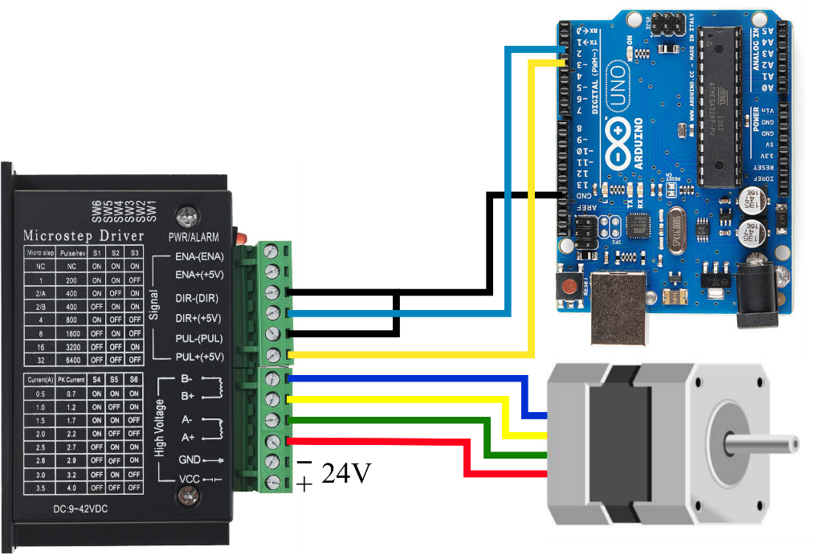
A stepper motor [NEMA23 in this lab] is a type of electric motor that moves in discrete steps, each representing a fixed rotation angle. This characteristic allows for precise control of position and speed, unlike the continuous rotation of conventional motors, stepper motors utilize a series of electromagnetic coils arranged around a central rotor, typically a permanent magnet, to achieve precise incremental movements.

The control of a stepper motor is achieved through the sequential activation of these electromagnetic coils, organized into phases. By energizing each phase in a predetermined order, the motor's rotor aligns with the magnetic fields generated by the stator coils, resulting in precise rotational steps. The fundamental relationship governing the stepper motor's operation is its step angle, which is determined by the motor's design:
$$\text{Step Angle} = \frac{{360}^{∘}}{\text{Number of Steps per Revolution}}$$
This equation highlights how the motor's structural configuration dictates the granularity of its movement.

Microstepping is a driving technique developed to enhance a stepper motor's resolution and smoothness of operation. By subdividing the motor's basic step angle, microstepping enables the rotor to position itself at fractions of a step. This is accomplished by proportionally adjusting the current in each phase, rather than simply switching the coils on and off. The result is a significantly increased number of positions per revolution, greatly enhancing precision and reducing mechanical resonance.

The essence of microstepping lies in its ability to finely control the motor's electromagnetic fields, allowing for intermediate positions between traditional steps. The degree of subdivision can vary, common ratios include 1/2, 1/4, 1/8, up to 1/256 of a step or more.

For a stepper motor with a step angle of 1.8°, such as the one used in this lab, employing a microstepping factor of 1/16 would yield a microstep angle of:
$$\text{Microstep Angle}=\frac{{1.8}^{∘}}{16}={0.1125}^{∘}$$
This finer control is achieved through the application of variable voltage to the motor coils, typically using Pulse Width Modulation (PWM) to achieve the desired current levels.


A microstep driver (stepper motor driver) for stepper motors is a device that translates low-power digital signals from a microcontroller into the high-power drive signals necessary to control a stepper motor. The driver's primary role is to manage the current sent to the motor's coils in such a way that the rotor moves in precise increments, or steps, allowing for fine-tuned control of the motor's position, speed, and acceleration.

Micro-step DIP Switch Settings
Micro-step | Pulse/rev | S1 | S2 | S3
NC | NC | ON | ON | ON
1 | 200 | ON | ON | OFF
2/A | 400 | ON | OFF | ON
2/B | 400 | OFF | ON | ON
4 | 800 | ON | OFF | OFF
8 | 1600 | OFF | ON | OFF
16 | 3200 | OFF | OFF | ON
32 | 6400 | OFF | OFF | OFF
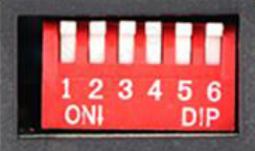
This driver has three DIP switches (S1, S2, S3) that set the microstep resolution. The resolution defines how many individual steps the motor will take to complete one full rotation. The "NC" (No Connection) setting disables any movement. The switches include settings labeled "2/A" and "2/B". The "2/A" setting is optimized for less jittery operation while the "2/B" setting is tailored for regular operation.

Another set of three DIP switches (S4, S5, S6) control the output current to the stepper motor. The settings range from 0.5A to 3.5A, allowing the user to adjust the motor's torque to match the load requirements.

Current DIP Switch Settings
Current(A) | Peak | S4 | S5 | S6
0.5 | 0.7 | ON | ON | ON
1 | 1.2 | ON | OFF | ON
1.5 | 1.7 | ON | ON | OFF
2 | 2.2 | ON | OFF | OFF
2.5 | 2.7 | OFF | ON | ON
2.8 | 2.9 | OFF | OFF | ON
3 | 3.2 | OFF | ON | OFF
3.5 | 4 | OFF | OFF | OFF
ENA+/ENA- (Enable) Pins are used to enable or disable the motor driver.

DIR+/DIR- (Direction) Pins determine the rotation direction of the stepper motor by applying power.

PUL+/PUL- (Pulse) Pins receive input signals that control the steps of the motor. Each pulse corresponds to a motor step.

Motor Connections (A+/A-, B+/B-) are the outputs from the driver to the stepper motor.

The driver operates within a range of 9V to 42V, accommodating various power systems. Our lab setup uses a 24V supply.

If the motor does not move when the step resolution is set high, often the torque is too low, meaning an increase in current is required.

For this lab we will need a DC power supply of 24 VDC.
We can use a simple brick-style power supply.
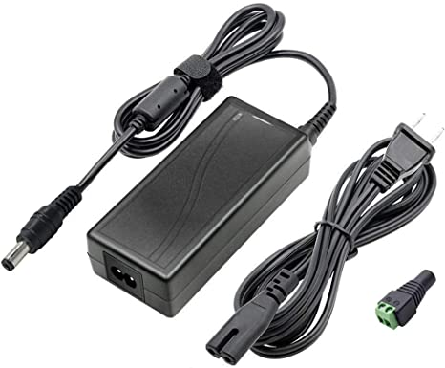

We can also use a benchtop power supply.
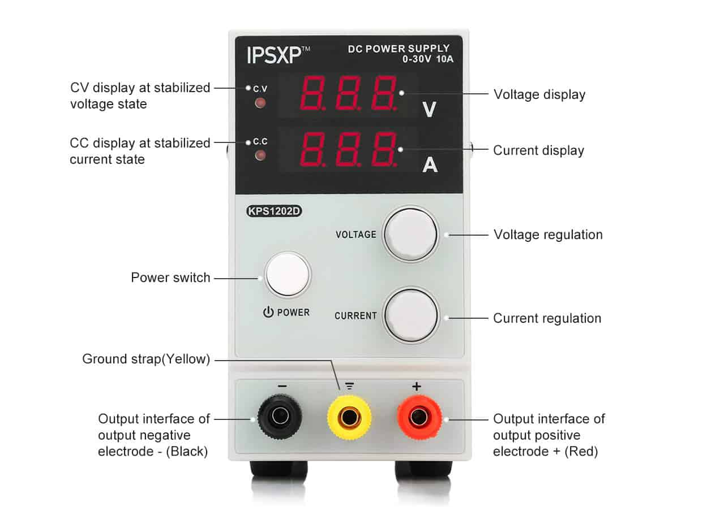

Exercise 1: Constant speed
In this lab session, the control of a stepper motor's speed using an Arduino will be demonstrated. This involves the conversion of a low-power signal from the Arduino's digital pins into a higher-power driving signal through a micro-stepper driver connected to an external power source. The micro-stepper driver and the power supply will be provided.

Building the Circuit:
- Connect the multi-colored cord to the stepper motor.
- Connect the Red wire to the A+ pin on the Microstep driver.
- Connect the Green wire to the A- pin on the Microstep driver.
- Connect the Yellow wire to the B+ pin on the Microstep driver.
- Connect the Blue wire to the B- pin on the Microstep driver.
- Connect the Arduino GND to the DIR- and PUL- pins on the Microstep driver.
- Connect the Arduino D2 to the DIR+ pin on the Microstep driver.
- Connect the Arduino D3 to the PUL+ pin on the Microstep driver.
- Connect the AC-DC power supply to the Microstep driver through the Vcc and GND.
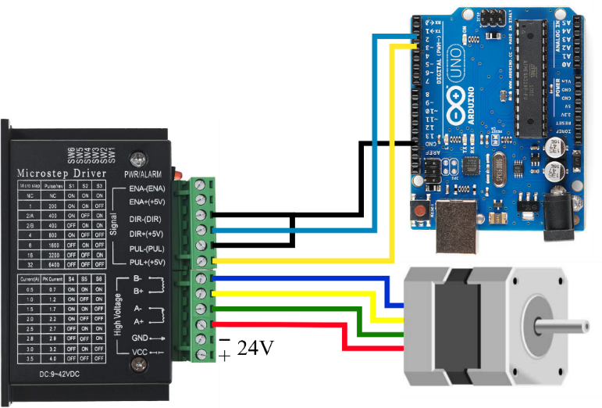
Writing the Program:
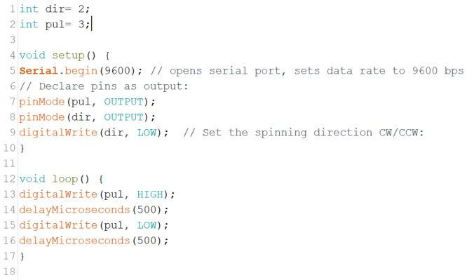
Exercise 2: Speed and direction control
Building on the previous exercise, functionality for user input is introduced to modify the stepper motor's speed and direction.

Instructions are as follows:
- Direction Switching via Button: A button circuit is integrated to alter the motor's direction. This is achieved by toggling the Arduino's direction pin (dir) between low and high states, effectively reversing the motor's rotation direction.
- Speed Control via Potentiometer: A potentiometer is used to adjust the motor's speed. The signal from the potentiometer, which varies within the analog-to-digital conversion (ADC) range of 0-1023, is processed using the map function. This function translates the ADC values to a narrower range of 0-500 microseconds.
- Implementation of Speed Adjustment: The output from the map function is then incorporated into the delayMicrosecond function within the control script. This is executed by adding the mapped value to the base delay, exemplified by delayMicrosecond(500 + userDelay), where userDelay represents the adjustment from the potentiometer.

Materials Required:
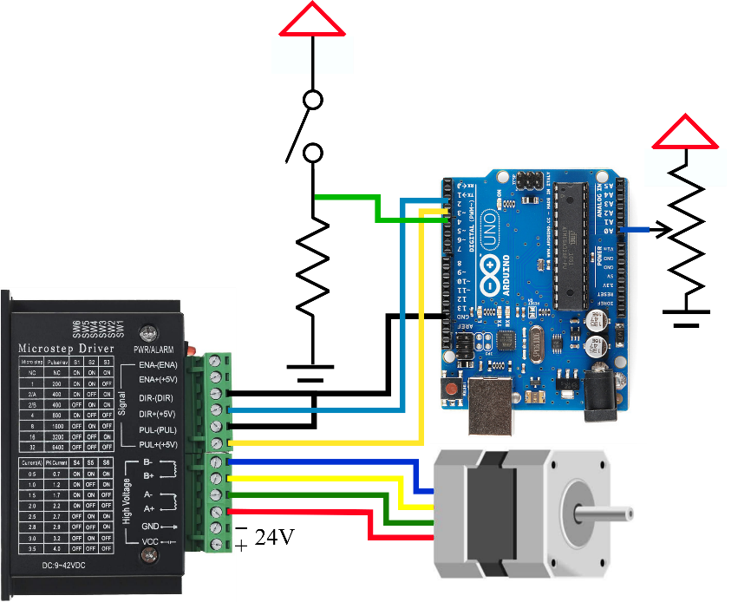
- A 10-kOhm resistor
- A button
- A potentiometer

Building the Circuit:
Use the schematic, construct a circuit on your breadboard that includes the switch and potentiometer as shown. This will enable the user to control the speed and direction of the stepper motor’s spin.

Writing the Code:
You are expected to modify the code given to you in the first exercise to include the speed and direction controls.

Helpful Link for Reference:
- [How Stepper motors work] https://www.youtube.com/watch?v=09Mpkjcr0bo
- [T6600HG Controller IC Datasheet] https://www.makerguides.com/wp-content/uploads/2019/10/TB6600HG-Datasheet.pdf
- [17HS4401S Motor Datasheet] https://datasheetspdf.com/pdf-file/1310364/Handson/17HS4401S/1

Lab 11 Grading Rubric:
- Exercise #1 Works properly, Motor spins with Constant speed (10 points)
- Exercise #2 Works properly, Speed and direction control (20 points)
- Adequately answer questions regarding the two exercises (20 points)

